## **Hands-On Activity: Adding code chunks to R Markdown notebooks**

**TOTAL POINTS 1**

1.

Question 1



In a previous hands-on activity, you created a visualization using the ggplot() function. In this activity, you will make use of the code you used to create that visualization and add it to your existing RMarkdown notebook.

### Adding Code Chunks to RMarkdown notebook



First, you will need a chunk of code that you want to add to your RMarkdown notebook. The code chunk below is from your ggplot() visualization:

**library(ggplot2)**

**library(palmerpenguins)**

**data(penguins)**

**View(penguins)**

**ggplot(data = penguins) +**

**geom_point(mapping = aes(x = flipper_length_mm, y = body_mass_g))**

Next, open your RMarkdown notebook and create a new code block section. Notebook chunks can be inserted quickly using the keyboard shortcut Ctrl + Alt + I (Windows) or Cmd + Option + I (Mac). Code chunks can also be added using the Insert menu in the editor toolbar.

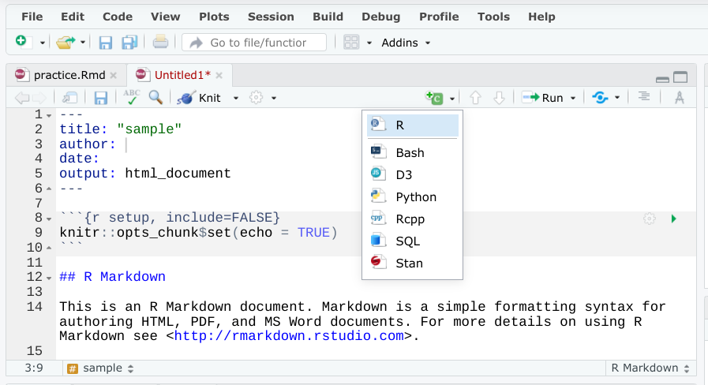

Code chunks are designated in R Markdown with delimiters*.* A delimiter is a character that indicates the beginning or end of a data item. In this case, the code chunk is marked using three ticks followed by a curly bracket, descriptive text, and a closed curly bracket. You then have an empty space to add the appropriate code. Here is the general syntax:

**```{r}**

**```**

When creating code chunks, it is useful to keep in mind that the output of the code chunk will appear immediately after the chunk when it is executed. Because of that, it is good practice to split chunks that produce multiple outputs into two or more chunks. That way, each code chunk is only producing one output, which can be easier for users to execute and explore. Using the code from your ggplot() visualization, you can create two new chunks. The first code chunk will call the required libraries, load the penguins data, and return a view of the penguins data:

**```{r ggplot for penguin data}**

**library(ggplot2)**

**library(palmerpenguins)**

**data(penguins)**

**View(penguins)**

**```**

Note that the only output from the code chunk is a tabular view of your data as result of the View function. The second code chunk will then create the visualization:

**```{r ggplot for penguin data visualization}**

**ggplot(data = penguins) +**

**geom_point(mapping = aes(x = flipper_length_mm, y = body_mass_g))**

**```**

Code chunks are a great way to explain your data analysis process and allow other users to explore your work. Try adding as many code chunks to your RMarkdown notebook as possible to make your notebook an interactive experience.

## Did you complete this activity?

1 point

Yes

No